

**COUNCIL ASSESSMENT REPORT**

HUNTER AND CENTRAL COAST REGIONAL PLANNING PANEL

|  |  |
| --- | --- |
| **PANEL REFERENCE & DA NUMBER** | PPSHCC-281 & DA/161/2024 |
| **PROPOSAL** | Subdivision |
| **ADDRESS** | 285, 295, 305, 315 and 325 Pacific Highway, Lake Munmorah NSW 2259 |
| **APPLICANT** | Barker Ryan Stewart |
| **OWNER** | Alda Properties (Lake Munmorah) Pty Ltd  Central Coast Council (6w Kemira Road)  Robin and Roxanne Becker  Rose Living Pty Ltd  Urban Land Redevelopment Pty Ltd |
| **DA LODGEMENT DATE** | 29 February 2024 |
| **APPLICATION TYPE** | Nominated Integrated Development (*Water Management Act 2000)* |
| **REGIONALLY SIGNIFICANT CRITERIA** | Clause 8 of Schedule 6 of the *State Environmental Planning Policy (Planning Systems) 2021* as it involves a coastal subdivision |
| **CIV** | $24,177,566 |
| **CLAUSE 4.6 REQUESTS** | Nil |
| **KEY LEGISLATION** | Coal Mine Subsidence Compensation Act 2017  National Parks and Wildlife Act 1974 (Aboriginal Heritage Impact Permit)  Rural Fires Act 1997  Water Management Act 2000  SEPP (Planning Systems) 2021  SEPP (Biodiversity and Conservation) 2021  SEPP (Resilience and Hazards) 2021  SEPP (Transport and Infrastructure) 2021  Central Coast Local Environmental Plan 2022 |
| **TOTAL AND UNIQUE SUBMISSIONS**  **KEY ISSUES IN SUBMISSIONS** | 23 unique submissions and one (1) petition with 309 signatures. |
| **DOCUMENTS SUBMITTED FOR CONSIDERATION** | * Plan of Subdivision * Civil Plans * Stormwater Management Report * Flood Impact Assessment * Traffic Impact Assessment * Noise Intrusion Report * Landscape Plans * Supplementary Contamination Report * Bushfire Assessment Report * Surface Water and Groundwater Baseline Assessment * Arborist Impact Assessment * EPBC Decision on Referral * Aboriginal Cultural Heritage Assessment Report * Biodiversity Management Plan * Project Cost Estimation * Waste Management Plan * Biodiversity Development Assessment Report * Road Safety Audit Report |
| **SPECIAL INFRASTRUCTURE CONTRIBUTIONS** | HPC Applicable |
| **RECOMMENDATION** | Approval subject to the Hunter Central coast Regional Planning Panel being satisfied the subdivision will facilitate the management and protection of the environmental values of the land in accordance with clause 4.1G |
| **SCHEDULED MEETING DATE** | 6 May 2025 |
| **PLAN VERSION** | T |
| **PREPARED BY** | Nathan Burr |
| **DATE OF REPORT** | 29 April 2025 |

**BACKGROUND**

The subject development application, DA/161/2024, seeks consent for a 285-lot land subdivision resulting in the creation of the following:

Two hundred and eighty-three (283) residential allotments, including two (2) split-zoned allotments (Lots 1 and 70) containing R2 Low Density Residential and C2 conservation land connected by vinculum, one drainage reserve (Lot 301), one public park (Lot 302), and internal roads and associated inground infrastructure.

On 25 March 2025 the Panel resolved to defer the determination of the development application for a number of reasons and provides a direction that the applicant provide information to address those matters. The Applicant and their relevant consultants have provided additional information and amended plans in response to the recommended deferral reasons included below.

1. *State Environmental Planning Policy (*Resilience and Hazards) 2021 (SEPP RH) Chapter 2 (Coastal Management) submission of information with respect to works proposed within the coastal wetland, and hydrological impacts associated with groundwater impacts associated with the engineering design and construction of the proposed subdivision works.
2. *Central Coast Local Environmental Plan 2022 –* Information to demonstrate compliance with the provisions of clause 4.1G(4)(a).
3. *Central Coast Local Environmental Plan 2022 –* Information to demonstrate the satisfactory provision of sewer services clauses 6.2 and 7.6, and stormwater drainage details demonstrating adequate stormwater drainage clause 7.6.
4. *Central Coast Local Environmental Plan 2022 –* Information to address the impacts of the development with respect to flooding in satisfaction of clause 5.21(2).
5. *Biodiversity Conservation Act 2016 –* Information to demonstrate works do not trigger the Biodiversity Offset Scheme.
6. A concept Construction Traffic Management Plan addressing the construction impacts associated with the construction phase of the development.

**CONSIDERATION OF DEFERRED MATTERS**

1. ***State Environmental Planning Policy (Resilience and Hazards) 2021 (SEPP RH) Chapter 2 (Coastal Management) submission of information with respect to works proposed within a coastal wetland, and hydrological impacts associated with groundwater impacts associated with the engineering design and construction of the proposed subdivision works.***

This deferral matter is comprised of two elements. Firstly, works were proposed within a coastal wetland and secondly concerns were raised in the assessment with regard to the potential for the subdivision works to impact groundwater, particularly in the area adjacent to the coastal wetland.

*WORKS WITHIN THE COASTAL WETLAND:*

The applicant has submitted amended engineering details which include rerouting the sewer originally proposed within the coastal wetland to the alignment of the Chisholm Road extension, connecting to the existing sewer main running generally north south within the Council Reserve. The sewer reticulation works, including the connection to the existing main, are within the bio-certified area. The proposed development, as amended, is no longer considered to comprise works with the coastal wetland.

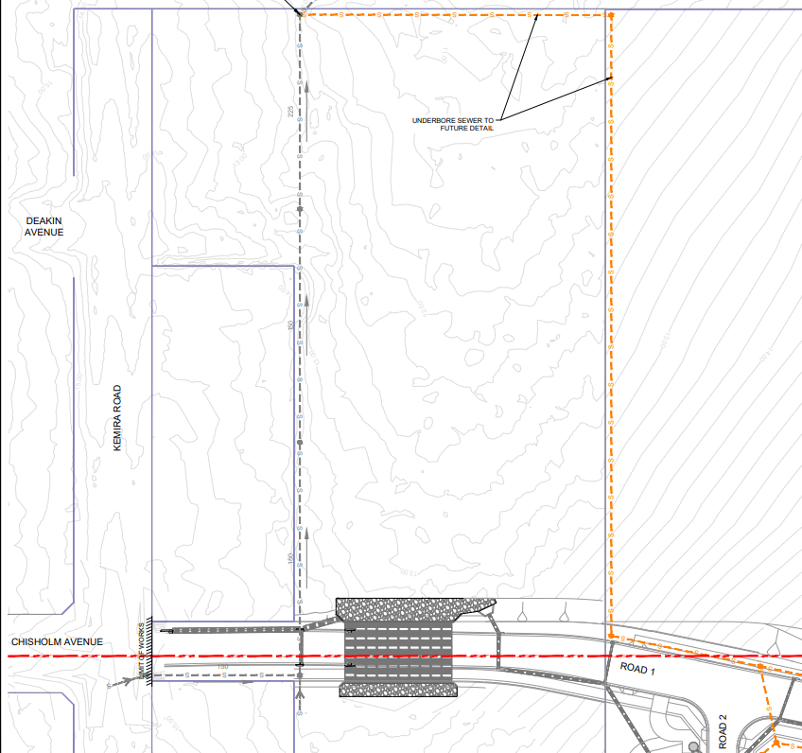

**Figure 1 –** Sewer main as originally proposal within the coastal wetland

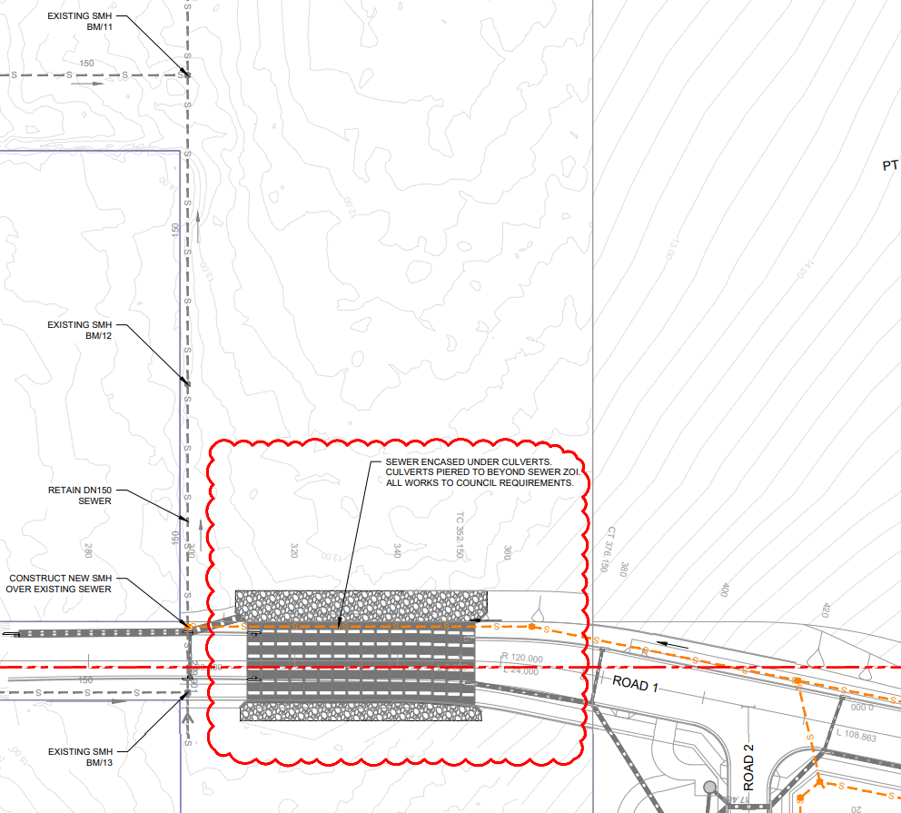

**Figure 2 –** Proposed sewer main along the Chisholm Road extension

*GROUNDWATER IMPACTS:*

A submission has been received from the Consulting Engineers with regard to the potential groundwater impacts An extract of their submission is included below.

*Stantec were provided with a cross section prepared by BRS (Rev. D, CC180099-07-545 and 721) of the proposed western culvert in the area of concern. The provided cross section indicates that proposed invert depths are approximately on grade with existing surface levels. Review with respect to previous groundwater assessments at the site indicates that the proposed invert of the western culvert is above the anticipated groundwater depth.*

*Given the presence of the gulley line, additional excavation may be required to remove unsuitable and facilitate a suitable bearing foundation for the western culvert. During previous investigations associated with the Supplementary Contamination Assessment [2] Stantec undertook a preliminary geotechnical assessment within the approximate location of the proposed western culvert. Based on the conditions at the time of assessment, the proposed invert depths and considering typical bearing capacity requirements for similar structures, less than 500 mm of over-excavation is anticipated. Such excavations during construction of the western culvert are still unlikely to encounter groundwater.*

Council’s Development Engineer has reviewed the additional information and is satisfied there will be minimal impact on groundwater during construction of the western culverts adjacent to the coastal wetland. If groundwater is encountered, it will be of a temporary/short term nature and could be appropriately managed by suitable construction techniques.

Based on the additional information and amended engineering design, the proposal is considered to satisfactorily address the concerns raised in the original assessment and the Panel may be satisfied that the development will not significantly impact on the following matters specified by Section 2.8 of *State Environmental Planning Policy (Resilience and Hazards) 2021,*

*(a) the biophysical, hydrological or ecological integrity of the adjacent coastal wetland or littoral rainforest, or*

*(b) the quantity and quality of surface and ground water flows to and from the adjacent coastal wetland or littoral rainforest.*

1. ***Central Coast Local Environmental Plan 2022 – Information to demonstrate compliance with the provisions of clause 4.1G(4)(a).***

The original assessment raised concerns relating to the proposed creation of two split zoned parcels that will include a dwelling parcel connected by vinculum to a much larger C2 zoned portion of land which is subject to biodiversity management requirements under the bio-certification framework applying to the site.

The concerns related to the operation of subclause 4.1G(4)(a) of the *Central Coast Local Environmental Plan 2022* (CCLEP 2022). Consent must not be granted under clause 4.1G unless the consent authority is satisfied of the following in accordance with clause 4.1G(4).

*(a) the subdivision will facilitate the management and protection of the environmental values of the land.*

The original assessment found that the application did not quantify the likely burden of the management of the C2 lands on the future owners and secondly demonstrate that the burden could be reasonably met. In this regard the subdivision was not shown to facilitate the management and protection of the environmental values of the land because it was not shown that the management of the land could be reasonably conducted by a future land owner, foreseeably a single household.

The consulting ecologist has undertaken a more detailed analysis of the potential future management requirements which have been summarised in a submission by the applicant which is included below.

*The applicant and its consulting ecologist Wedgetail have adopted council’s ecologist estimate of the annual financial burden on the future homeowners [of lot 1 and Lot 70]:*

* *Drainage lot: Bush regeneration 4 visits per year x $1500= $6000*
* *Scribbly Gum corner lot: Bush regeneration 4 visits per year x half day ($750)= $3000*
* *Shared across both (as final location of boxes not known): Nest box renewal (informed by Pacific highway nest box attribution of 7% year)= 11 boxes @ $200 a box installed= $2200*
* *Additionally, Wedgetail have provided a consideration for general maintenance items like fence repair and rubbish removal, etc.*

*In your email of 11 April Council also asked if “The consulting ecologist may be able to provide more accurate details for the RPP to consider and decide whether in its view the amounts are reasonably attributable to a household.”*

*To address, Councils question, an indicative management/maintenance budget was calculated beyond 10 years (year 11 to in perpetuity) using the Total Fund Deposit (TFD) calculator. The TFD calculator is the industry recognised tool in New South Wales used to calculate management budgets for Biodiversity Stewardship Sites (BSA Sites). The calculation determines:*

*The value of Discount a purchaser of Lot 1 and/or Lot 70 would receive in order to be able to self-fund the year 11 to in perpetuity maintenance program detailed in the Final Monitoring Report as approved by the BCS.*

*Or*

*The Total Fund Deposit that a vendor would need to put in place to equip all future landowners (purchasers) to undertake the likely year 11 to in perpetuity maintenance program as detailed in the Final Monitoring Report as approved by the BCS.*

*In practice option 1 – Discount, is the generally preferred method adopted by vendors and purchasers in Contracts of Sale of privately owned C2 land.*

*The Discount a purchaser will seek or Total Private Fund Deposit a vendor could provide to a purchase at year 11 totals $393,129.00. This arrangement will need to be via two separate contract of sale terms between vendor and purchaser of the respective properties: Lot 70: $262,064; and Lot 1: $131,065.*

*The Final Monitoring Report approved by the BCS, detailing the in-perpetuity management/maintenance obligations and a potential corresponding calculation of Discount or Total Private Fund Deposit calculation, will ultimately be subject to approval by the Minister of Environment’s delegate in accordance Clause 3.3.1 of the BMP and to the satisfaction of the respective future vendors and purchasers.*

*The applicant is of the view that Council should be satisfied that clause 4.1G(4)(a) of the Central Coast Local Environmental Plan 2022 (ie. to facilitate the management of the C2 zoned land) are achieved by:*

* *The Contractual and Registration on title of the BCA which Council and the landowner’s are all signatories to with the Minister of the Environment including compliance with the BMP;*
* *The BMP having been approved by Council and BCS; and*
* *The additional information provided in Wedgetail’s letter dated 16 April 25 illustrating that the Final Monitoring Report approved by the BCS, will detail the in-perpetuity management/maintenance obligations and a corresponding calculation of Discount or Total Private Fund Deposit calculation, which will ultimately be subject to approval by the Minister of Environment’s delegate in accordance Clause 3.3.1 of the BMP and to the satisfaction of the respective future vendors and purchasers who have the responsibility and accountability via the BCA registered on title and the BCS and Council approved BMP to deliver “implementation” and “maintenance” works on the C2 lands at proposed future Lot 1 and Lot 70.*

The Applicant’s lawyer subsequently provided further commentary in response to discussions with Council’s Solicitor in relation to options available for potential funding mechanisms for the C2 land which could support the works required under the Biodiversity Management Plan (BMP).

*For the benefit of the Applicant and Council, set out below are three possible solutions discussed with you today:*

1. *Imposing a condition requiring a financial assurance under* [*section 4.17*](https://aus01.safelinks.protection.outlook.com/?url=https%3A%2F%2Flegislation.nsw.gov.au%2Fview%2Fhtml%2Finforce%2Fcurrent%2Fact-1979-203%23sec.4.17&data=05%7C02%7Cnathan.burr%40centralcoast.nsw.gov.au%7C36b75dd2ade14584037f08dd822d96fe%7C479e69d178bc4e1a81dd047fe9928e1f%7C0%7C0%7C638809854982249393%7CUnknown%7CTWFpbGZsb3d8eyJFbXB0eU1hcGkiOnRydWUsIlYiOiIwLjAuMDAwMCIsIlAiOiJXaW4zMiIsIkFOIjoiTWFpbCIsIldUIjoyfQ%3D%3D%7C0%7C%7C%7C&sdata=tNoTLR%2Bkdjw%2ByL8b8mDzPycuKDCqemOjnJ0eLlOAgxE%3D&reserved=0)*(4B) of the EPA Act.  However, this does not work for two reasons:* 
   1. *pursuant to* [*section 78*](https://aus01.safelinks.protection.outlook.com/?url=https%3A%2F%2Flegislation.nsw.gov.au%2Fview%2Fhtml%2Finforce%2F2025-04-04%2Fsl-2021-0759%23sec.78&data=05%7C02%7Cnathan.burr%40centralcoast.nsw.gov.au%7C36b75dd2ade14584037f08dd822d96fe%7C479e69d178bc4e1a81dd047fe9928e1f%7C0%7C0%7C638809854982263398%7CUnknown%7CTWFpbGZsb3d8eyJFbXB0eU1hcGkiOnRydWUsIlYiOiIwLjAuMDAwMCIsIlAiOiJXaW4zMiIsIkFOIjoiTWFpbCIsIldUIjoyfQ%3D%3D%7C0%7C%7C%7C&sdata=DB9teE7fgx%2Fz1KHAvQNBU3M%2B0nbEZZ8JTEoP2nEW8p0%3D&reserved=0) *of the EPA Regulation, section 4.17(4B) applies only if the development is State significant development; and*
   2. *even if section 4.17(4B) applied, it does not address the issue of who would be responsible for administering the financial assurance.  However, we understand from your comments that Council is unlikely to agree to take on the obligation of administering the security.*

1. *Amending the development to community title subdivision to enable the Conservation Land to be managed by the Community Association as community property.  We do not consider this to be an appropriate solution as:* 
   1. *there is no requirement under clause 4.1G for the subdivision to be undertaken as community title subdivision; and*
   2. *it is unreasonable for the Council to require the subdivision to be converted to community title at this late stage of the DA process.*

1. *Imposing a condition requiring entry into a VPA for the developer to provide a security to fund the maintenance works at Year 11.  However, we do not consider this to be an appropriate solution as it requires the developer to administer the security for successive landowners, which is not an ideal planning outcome.  Further, we understand that Council is unlikely to be willing to administer the security.*

*As discussed, whilst the Applicant is not necessarily opposed to a mechanism to provide for the ongoing funding of the Conservation Land, the Applicant does not consider such funding is required to satisfy the consent authority as it is neither contemplated nor required by the express terms of* [*clause 4.1G*](https://aus01.safelinks.protection.outlook.com/?url=https%3A%2F%2Flegislation.nsw.gov.au%2Fview%2Fhtml%2Finforce%2Fcurrent%2Fepi-2022-0308%23sec.4.1G&data=05%7C02%7Cnathan.burr%40centralcoast.nsw.gov.au%7C36b75dd2ade14584037f08dd822d96fe%7C479e69d178bc4e1a81dd047fe9928e1f%7C0%7C0%7C638809854982277334%7CUnknown%7CTWFpbGZsb3d8eyJFbXB0eU1hcGkiOnRydWUsIlYiOiIwLjAuMDAwMCIsIlAiOiJXaW4zMiIsIkFOIjoiTWFpbCIsIldUIjoyfQ%3D%3D%7C0%7C%7C%7C&sdata=e%2FJUBLzexcXVVXxtwrPPMYQThDplAAJLj6oVu51jg%2Bg%3D&reserved=0) *of the Central Coast Local Environmental Plan 2022.  Paragraph (4)(a) requires only that the consent authority be satisfied that the subdivision will facilitate the management and protection of the environmental values of the land.*

*If the legislature had intended that funding was necessary to the meet the requisite level of satisfaction under clause 4.1G then it would have expressly included drafting to this effect (see, for example,* [*section 27*](https://aus01.safelinks.protection.outlook.com/?url=https%3A%2F%2Flegislation.nsw.gov.au%2Fview%2Fhtml%2Finforce%2Fcurrent%2Fact-2016-020%23sec.27&data=05%7C02%7Cnathan.burr%40centralcoast.nsw.gov.au%7C36b75dd2ade14584037f08dd822d96fe%7C479e69d178bc4e1a81dd047fe9928e1f%7C0%7C0%7C638809854982290306%7CUnknown%7CTWFpbGZsb3d8eyJFbXB0eU1hcGkiOnRydWUsIlYiOiIwLjAuMDAwMCIsIlAiOiJXaW4zMiIsIkFOIjoiTWFpbCIsIldUIjoyfQ%3D%3D%7C0%7C%7C%7C&sdata=etG8m0Tm24PViQ%2BWrG1RaW0zJXjNR6QjJ%2Bgn%2F2qXOYg%3D&reserved=0)*(2) of the Coastal Management Act 2016).*

*The Applicant remains of the view that the consent authority can be satisfied that the proposed subdivision satisfies clause 4.1G(4)(a) as the management of the Conservation Land is facilitated via the registration of the Biodiversity Certification Agreement (BCA) on title to the land, which imposes requirements for the management and maintenance of the land in perpetuity.*

*Each successive landowner will be required to comply with the requirements of the BCA.  The BCA also requires the landowners to provide notice of the BCA to the purchaser of any land to which the BCA relates.  Therefore, any subsequent sales (beyond the initial sale) would be subject to a proportionately discounted sale price to enable the ongoing management of the land by successive landowners.  To the extent there is any non-compliance with the BCA, the Minister may take action rectify the contravention, including by entering the land to carry out the required work (*[*s 8.18*](https://aus01.safelinks.protection.outlook.com/?url=https%3A%2F%2Flegislation.nsw.gov.au%2Fview%2Fhtml%2Finforce%2Fcurrent%2Fact-2016-063%23sec.8.18&data=05%7C02%7Cnathan.burr%40centralcoast.nsw.gov.au%7C36b75dd2ade14584037f08dd822d96fe%7C479e69d178bc4e1a81dd047fe9928e1f%7C0%7C0%7C638809854982303229%7CUnknown%7CTWFpbGZsb3d8eyJFbXB0eU1hcGkiOnRydWUsIlYiOiIwLjAuMDAwMCIsIlAiOiJXaW4zMiIsIkFOIjoiTWFpbCIsIldUIjoyfQ%3D%3D%7C0%7C%7C%7C&sdata=%2BaRyTBqqaeAuUw9L%2FEO7fy9C7w3mJP8emb%2Bo%2Fw9GajU%3D&reserved=0)*(3)(a) Biodiversity Conservation Act 2016).*

*In addition, we remind Council and the Panel that a consent authority is confined in relation to the imposition of conditions requiring the provision of security by* [*section 4.17*](https://aus01.safelinks.protection.outlook.com/?url=https%3A%2F%2Flegislation.nsw.gov.au%2Fview%2Fhtml%2Finforce%2Fcurrent%2Fact-1979-203%23sec.4.17&data=05%7C02%7Cnathan.burr%40centralcoast.nsw.gov.au%7C36b75dd2ade14584037f08dd822d96fe%7C479e69d178bc4e1a81dd047fe9928e1f%7C0%7C0%7C638809854982316917%7CUnknown%7CTWFpbGZsb3d8eyJFbXB0eU1hcGkiOnRydWUsIlYiOiIwLjAuMDAwMCIsIlAiOiJXaW4zMiIsIkFOIjoiTWFpbCIsIldUIjoyfQ%3D%3D%7C0%7C%7C%7C&sdata=OAKLQOv%2Bzi1z8x3yY9k0EKkFlCzmaad9QsmxaAoEaKE%3D&reserved=0)*(6) of the Environmental, Planning and Assessment Act 1979 (EPA Act).  We note that a condition requiring financial assurance under section 4.17(4B) of the EPA Act is not available as it applies only if the development is State significant development (*[*section 78*](https://aus01.safelinks.protection.outlook.com/?url=https%3A%2F%2Flegislation.nsw.gov.au%2Fview%2Fhtml%2Finforce%2F2025-04-04%2Fsl-2021-0759%23sec.78&data=05%7C02%7Cnathan.burr%40centralcoast.nsw.gov.au%7C36b75dd2ade14584037f08dd822d96fe%7C479e69d178bc4e1a81dd047fe9928e1f%7C0%7C0%7C638809854982329790%7CUnknown%7CTWFpbGZsb3d8eyJFbXB0eU1hcGkiOnRydWUsIlYiOiIwLjAuMDAwMCIsIlAiOiJXaW4zMiIsIkFOIjoiTWFpbCIsIldUIjoyfQ%3D%3D%7C0%7C%7C%7C&sdata=n5fIDOGhHwvQddMVVWoFEzv%2BtwR5gFMrRWccgXdxpvI%3D&reserved=0) *of the EPA Regulation).*

*Given the above, we implore Council’s planning team to act reasonably and recommend that the development be approved, as the requisite level of satisfaction under clause 4.1G(4) is achieved by the BCA, which Minister and Council are both parties to.*

It is considered the Applicant has appropriately identified the extent and likely costs of works associated with the ongoing obligations under the BMP. However, it is considered the financial obligations are significant in the context of a single household, and there have been no mechanisms identified to ensure the BMP works can be funded.

Notwithstanding, if the Panel is satisfied the subdivision facilitates the management and protection of the environmental values of the land by virtue of the Biodiversity Certification Agreement and associated Biodiversity Management Plan, the Panel as the consent authority may grant consent.

1. ***Central Coast Local Environmental Plan 2022 – Information to demonstrate the satisfactory provision of sewer services clauses 6.2 and 7.6, and stormwater drainage details demonstrating adequate stormwater drainage clause 7.6.***

The original assessment identified that the proposal did not have adequate arrangements for the provision of sewer or stormwater as required by clauses 6.2 and 7.6 of CCLEP 2022.

*SEWER:*

The original sewer design included the construction of sewer mains through a coastal wetland which could not be approved. As discussed in relation to deferred matter *a)* above, the development has been amended to provide a sewer alignment that does not encounter the coastal wetland. The location, design and capacity of the proposed sewer has been reviewed by Council’s Water and Sewer Engineer and found to be acceptable.

*STORMWATER:*

The development will convey stormwater from the Pacific Highway and the original assessment identified that sufficient provision had not been made for the conveyance of stormwater through the site.

In response to the concerns raised, the Consulting Engineer has provided the following commentary in relation to the design depicted in the plan extract further below.

1. *Inlet pit shall be designed with 50% blockage factor to eliminate the need for a formal downstream overland flow path.*
2. *50% blockage factor has been applied to the inlet pit.*
3. *Pit to accept full 1% AEP flows (1% AEP flow = 1.72m³/s).*
4. *Minimum pit size required is 2.9 x 1.2m, including allowance for 50% blockage.*
5. *Pit to include a raised grate on legs to minimise blockage potential.*
6. *Updated arrangement is presented on the attached drawing CC180099-SK12-A.*
7. *The pipe network from the above inlet pit to the downstream discharge headwall shall convey the 1% AEP flows.  Barrel blockage is not required.*
8. *With reference to the Drains model screen grab presented on SK12-A, the nominated 2xDN675 pipes are adequate to convey the 1% AEP flows from the Highway to proposed internal Road 2.*
9. *On this basis, it is understood that a formal overland flow channel is not required over the 2x DN675 pipes.*
10. *Confirm the requirements and extent of scour protection at the discharge headwall at the park, ensuring no works within the C2 land*
11. *Discharge to the downstream headwall at the park is via a 600mm high box culvert.*
12. *1% AEP flow velocity at outlet is 3.2m/s.*
13. *Required scour protection is hard, durable rock, d50 = 300mm, nom. 600mm overall thickness, underlain by approved geotextile (or equivalent works, ie rock mattress or similar).*
14. *Required length of the scour protection is 2.4m beyond the headwall apron.*
15. *Scour currently shown at 3m long.*
16. *Discharge from headwall apron to downstream C2 land is 5.74m.*
17. *Refer to details presented on attached SK12-A.*
18. *Council’s preference is for the current drainage easement on Lot 200 to be a dedicated Council Drainage Reserve*
19. *Lot 200 currently includes a 3.5m wide drainage easement to house the proposed 2x DN675 pipes.  The easement meets the requirements of CCC Design Specification, C10.8.1 General Requirements Easements.*
20. *It is understood that Council’s preference is for the 3.5m drainage easement to be dedicated to Council as a Drainage Reserve.*
21. *Dedication of the 3.5m drainage easement as a Drainage Reserve will result in Lot 200 being 15m wide with an area of approximately 566m².  This exceeds Council’s 450m² minimum lot size.*
22. *A dedicated 3.5m wide Drainage Reserve is therefore possible while maintaining compliance for Lot 200.*
23. *From an urban design viewpoint, it is considered that a drainage easement on private land presents a better development outcome than a Drainage Reserve.*
24. *Further, through previous discussions with Council, there was a desire from a safety viewpoint to only have pedestrian access from the Highway to the site in the south-west corner (near the shopping centre and close to the Tall Timbers Road traffic signals).  This arrangement limited the potential demand to cross the Highway in an uncontrolled manner to reach the Bowling Club and other destinations on the southern side of the Highway.*
25. *On this basis, it is considered that the 3.5m wide easement as currently presented is appropriate.*

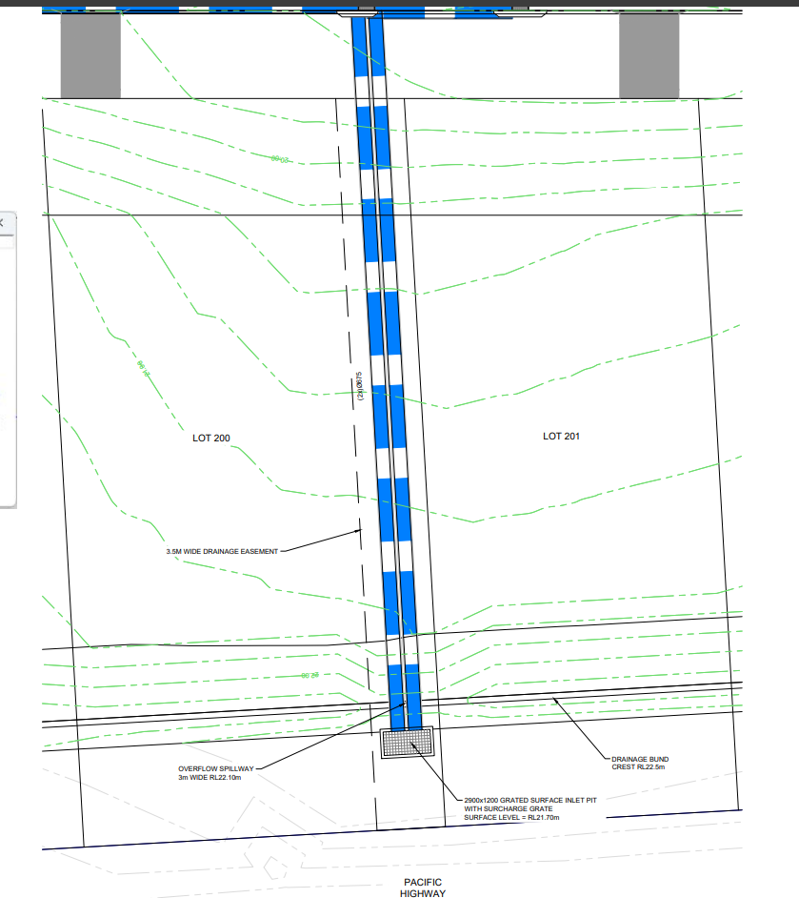

**Figure 3 –** Proposed Infrastructure to accommodate Pacific Highway drainage

Council’s Development Engineer has reviewed the revised stormwater design and is of the view that flood levels on the highway will not be impacted from downstream drainage works. The open channel through Lot 200 has now been sized to cater for the full 1% AEP event, which will cater for flows if the inlet structure becomes fully blocked. This is demonstrated in the flood modelling extract below. Having regard for the additional information, the development is considered to incorporate satisfactory stormwater drainage.

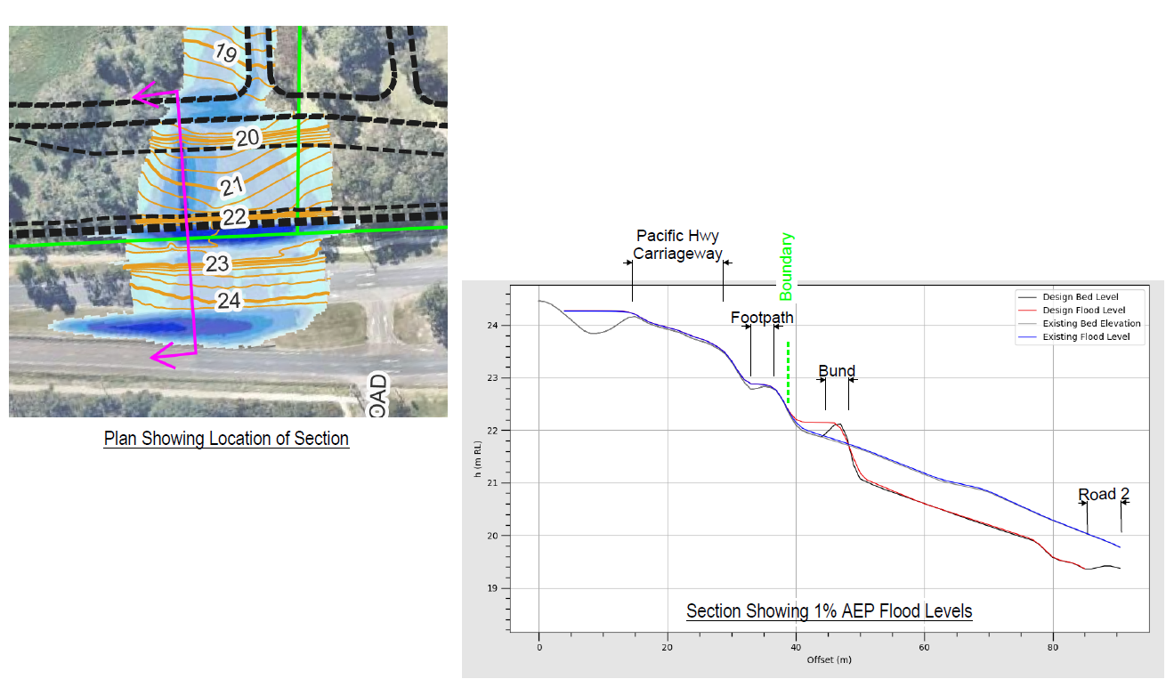

**Figure 4 –** Flood Modelling depicted post development Pacific Highway flood levels

The Panel may be satisfied that adequate public utility infrastructure essential for the proposed development is available and that services essential for the development are available or adequate arrangements have been made to make the services available when required in satisfaction of clauses 6.2 and 7.6 of CCLEP 2022.

1. ***Central Coast Local Environmental Plan 2022 – Information to address the impacts of the development with respect to flooding in satisfaction of clause 5.21(2).***

The original assessment identified potential flood impacts, particularly in the area described as the rear portions of the lots from No.’s 2 to 10 Kemira Road Lake Munmorah. In response to this the Applicant provided an amended design of the Chisholm Road extension, increasing the culvert capacity to improve flows. The Consulting Engineer provided the following summary of the flood assessment and culvert design requirements.

*Areas of Concern*

1. *Existing flood hazard on adjoining property should be maintained or reduced during a PMF event.*
2. *Flood hazard is a more critical concern than flood levels changes.*
3. *A blockage assessment of the proposed culvert set undertaken in accordance with ARR2019 guidelines will be considered on its merits.*

*Response to Areas of Concern*

1. *A site-specific blockage assessment has been undertaken in accordance with ARR2019 Guidelines.*

* *A design blockage factor of 10% has been adopted per the attached blockage assessment.*

1. *The site flood model has been updated with 14x 2400W x 600H RCBCs with nil blockage.*

* *Thus, with a 10% blockage factor, a total of 16 culvert units is required (14 units x 1.1 = 15.4 = 16 culvert units, which equates to an actual blockage factor of 14%)*

1. *The attached PMF maps show negligible change in the portion of 2, 4 & 6 Kemira Road mapped as H3.*
2. *We consider this negligible change to be within the limits of the flood model for the PMF event.*

A plan extract of the revised culvert design and the pre and post development flood modelling are included below.

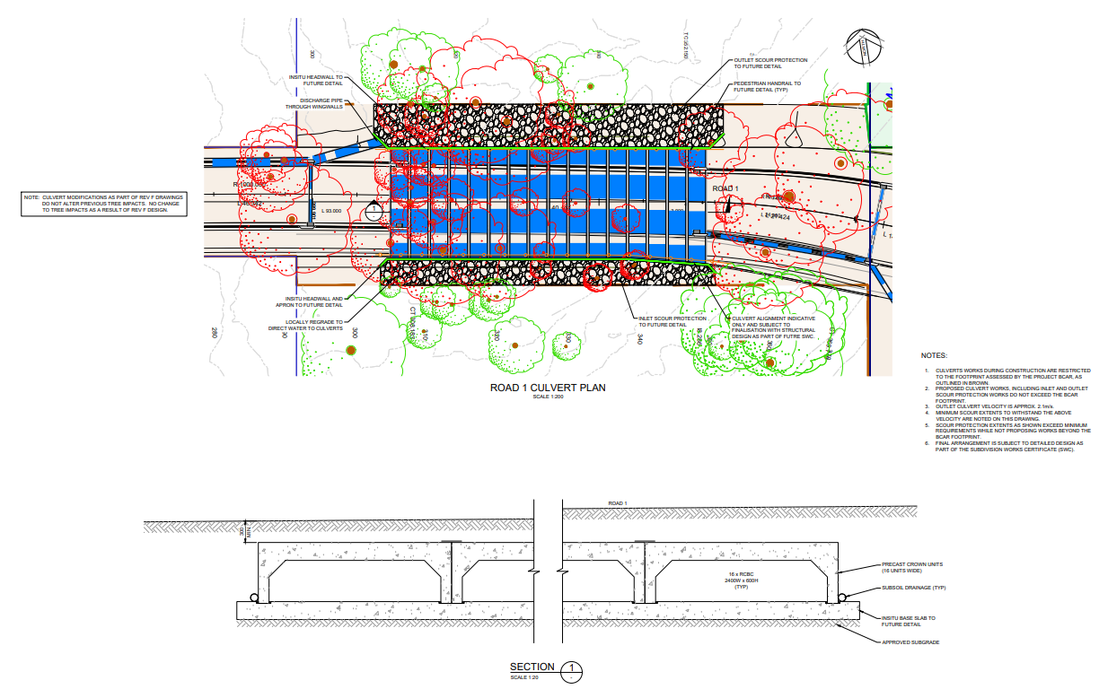

**Figure 5 –** Proposed Chisholm Avenue Extension Culvert Crossing

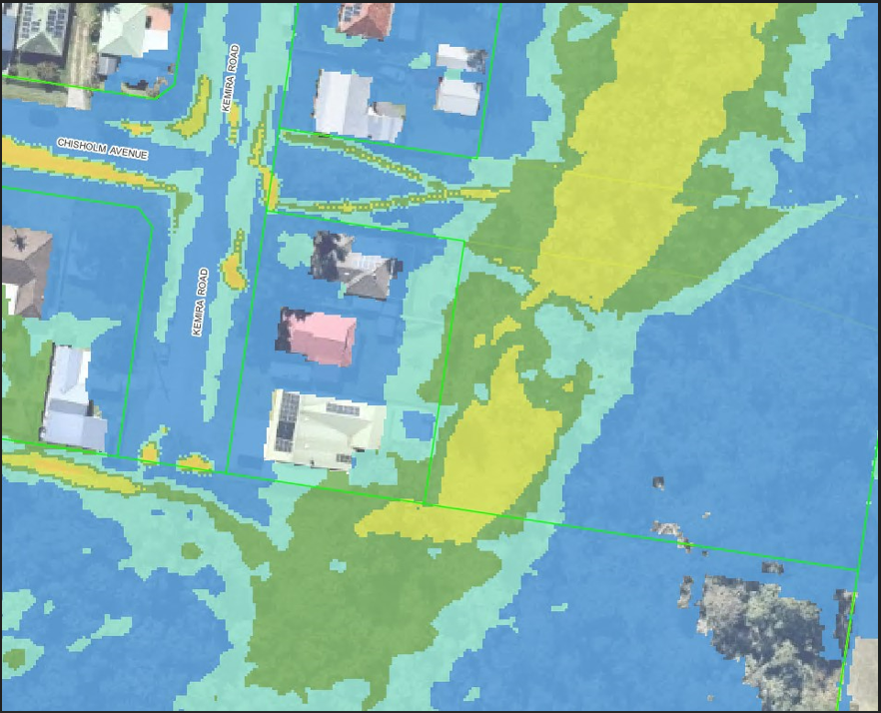

**Figure 6 –** PMF level Pre-Development - Chisholm/Ave Kemira Rd

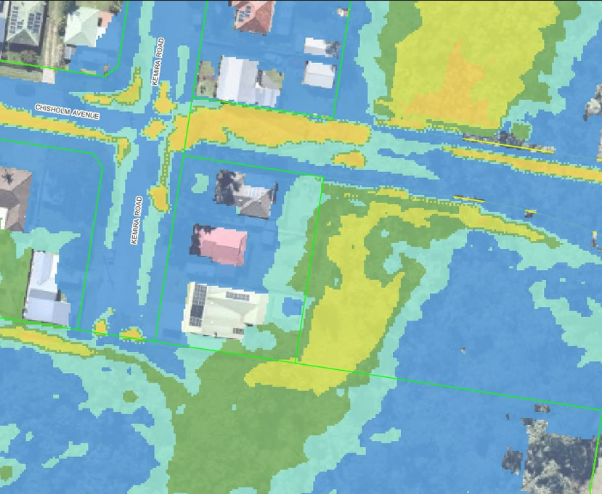

**Figure 7 –** PMF level Post Development - Chisholm/Ave Kemira Rd

Council’s Flooding Engineer has reviewed the proposal in terms of clause 5.21 of CCLEP 2022 and has concluded that the Panel may be satisfied the development meets the provisions of clause 5.21, subject to the recommended conditions of consent. Accordingly, the proposed development:

1. Is compatible with the flood function and behaviour on the land, and
2. Will not adversely affect flood behaviour in a way that results in detrimental increases in the potential flood affectation of other development or properties, and
3. Will not adversely affect the safe occupation and efficient evacuation of people or exceed the capacity of existing evacuation routes for the surrounding area in the event of a flood, and
4. Incorporates appropriate measures to manage risk to life in the event of a flood and
5. Will not adversely affect the environment or cause avoidable erosion, siltation, destruction of riparian vegetation or a reduction in the stability of riverbanks or watercourses.
6. ***Biodiversity Conservation Act 2016 – Information to demonstrate works do not trigger the Biodiversity Offset Scheme.***

The original assessment identified a number of areas where it was not clear if the proposed or associated works would encounter vegetation mapped on the NSW Biodiversity Values Map, which would ordinarily trigger the requirement for a Biodiversity Development Assessment Report to be prepared for the works.

Subsequently the Applicant has provided details that demonstrate works within Tall Timbers Road are not within land identified on the NSW Biodiversity Values Map and therefore a BDAR is not required for those works.

The amended engineering plans and Arborist Report show all works and tree removal on site on Lot 79 occur within the Biocertified area, and outside the avoidance and conservation areas.

1. ***A concept Construction Traffic Management Plan addressing the construction impacts associated with the construction phase of the development.***

The Applicant has submitted a Construction Traffic Management Plan (CTMP) which articulates the type of vehicles, the means of access to the site for construction purposes, an indicative schedule of works and provides details to demonstrate construction vehicles can be accommodated within the local and classified road network. It is considered that the CTMP provides for an appropriate consideration of the impacts of the development and

**CONCLUSION**

The application has been considered in accordance with the requirements of the EP&A Act and the Regulations, as outlined in this supplementary report and the original assessment report. The following is a summary of prerequisite conditions for the granting of development consent that have been considered in the assessment report and provided as part of the conclusion, for the benefit of the Panel:

* The Panel can be satisfied that the relevant General Terms of Approval have been obtained from the NSW Rural Fire Service in accordance with section 4.47(2) of the *Environmental Planning and Assessment Act, 1979*, and that the recommended conditions of consent are consistent with the General Terms of Approval in accordance with section 4.47(3) of the *Environmental Planning and Assessment Act, 1979*.
* In accordance with Chapter 4, section 4.9(2) of the *State Environmental Planning Policy (Biodiversity and Conservation) 2021,* the Panel can be satisfied that the development will have no impacts upon koalas or koala habitat.
* Having regard for Sections 2.8 of *State Environmental Planning Policy (Resilience & Hazards) 2021*, the Panel can be satisfied that the proposed development is designed, sited, and will be managed to avoid an adverse impact referred to in s.2.8(1) and the development is not likely to cause increased risk of hazards on the subject site or other land.
* The Panel can be satisfied that the land is suitable for the proposed development having regard for the provisions of section 4.6 *State Environmental Planning Policy (Resilience and Hazards) 2021*.
* Having regard for the prerequisite conditions to the granting of consent under the *Central Coast Local Environmental Plan 2022,* the Panel can be satisfied that:
  + Clause 5.21 – Flood Planning

The proposed development:

1. Is compatible with the flood function and behaviour on the land, and
2. Will not adversely affect flood behaviour in a way that results in detrimental increases in the potential flood affectation of other development or properties, and
3. Will not adversely affect the safe occupation and efficient evacuation of people or exceed the capacity of existing evacuation routes for the surrounding area in the event of a flood, and
4. Incorporates appropriate measures to manage risk to life in the event of a flood and
5. Will not adversely affect the environment or cause avoidable erosion, siltation, destruction of riparian vegetation or a reduction in the stability of riverbanks or watercourses.
   * Clause 6.2 – Public Utility Infrastructure

All relevant public utility infrastructure essential to the development services are available to service the development.

* + Clause 7.6 – Essential services

All services essential for the proposed development remain available to the subject site.

**RECOMMENDATION**

That Development Application No. 161/2024 be APPROVED pursuant to Section 4.16(1)(a) of the *Environmental Planning and Assessment Act 1979* subject to the Hunter Central Coast Regional Planning Panel being satisfied the subdivision will facilitate the management and protection of the environmental values of the land, and the draft conditions attached to this report at Attachment A.

The following attachments are provided:

* Attachment A – Draft Conditions of Consent
* Attachment B – Applicant’s Submissions Addressing Matters for Deferral
* Attachment C – Revised Engineering Details
* Attachment D – Legal Correspondence – Corrs Chambers Westgarth
* Attachment E – Record of Deferral